Digital Communication Systems

**Laboratory Report**

Spring 2024

|  |  |
| --- | --- |
| Laboratory Number: | **6** |
| Laboratory Title: | **Passband Transmission: Binary Phase Shift Keying (BPSK)** |
| Full Name: | **Leo Berman** |
| TUID: | **916027207** |

**Introduction:**

The purpose of this lab is to investigate the effects of utilizing digital pass-band transmission and reception. In order to do this, we want to implement a BPSK modulator and demodulator. Once we have transmitted and received this modulated signal, we want to evaluate performance by calculating probability of error in comparison to the Energy Per Bit to Noise ratio.

**Procedure:**

Before Starting:

1. Define amplitude and bit rate based off your TUID and define some other parameters.

|  |
| --- |
| tuid = [9,1,6,0,2,7,2,0,7];  A = tuid(9) + 2; % amplitude [Volts]  rb = 1000 * (tuid(8) + 3); % Bit rate  Tb = 1/rb; % Bit interval  fc = 20*rb; % Carrier frequency  fs = 20*fc; % Sampling frequency  Ts = 1/fs; % Sampling interval  Ns = floor(Tb/Ts); % Number of samples per bit  N = 10000; % Number of bits to be transmitted |

Task 1:

1. Generate a binary signal
2. Use PNRZ to encode the signal
3. Generate a carrier wave
4. Take the generated binary encoded signal and multiply it component wise by the carrier wave
5. Generate a series of reference pulses
6. Iterate from -10 to 10 dB Energy per bit to Noise ratio calculating the error rate & theoretical error rate of the decoded signal
7. Plot the results with a log incremented y axis being the two error rates and the x axis being the Energy per bit to Noise ratio.

Task 2:

1. Generate a binary signal
2. Use PNRZ to encode the signal
3. Generate a carrier wave
4. Take the generated binary encoded signal and multiply it component wise by the carrier wave
5. Calculate & plot the power spectral density by way of the Fast Fourier Transform (fft)

**Results:**

Task 1:

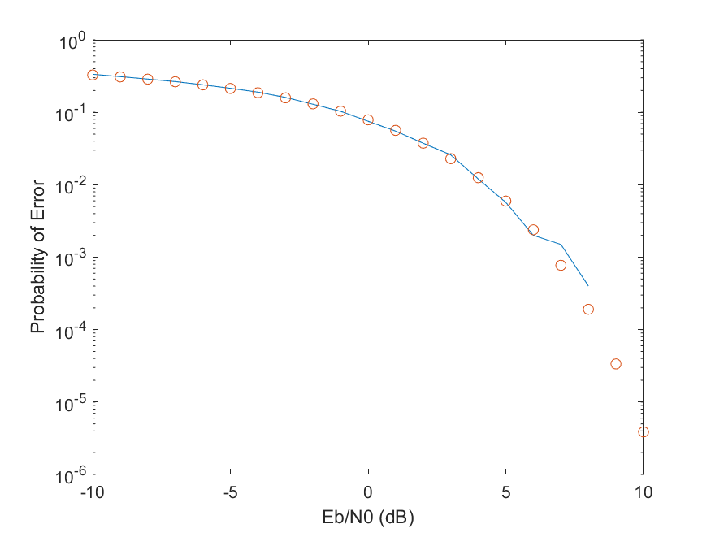

Task 2:

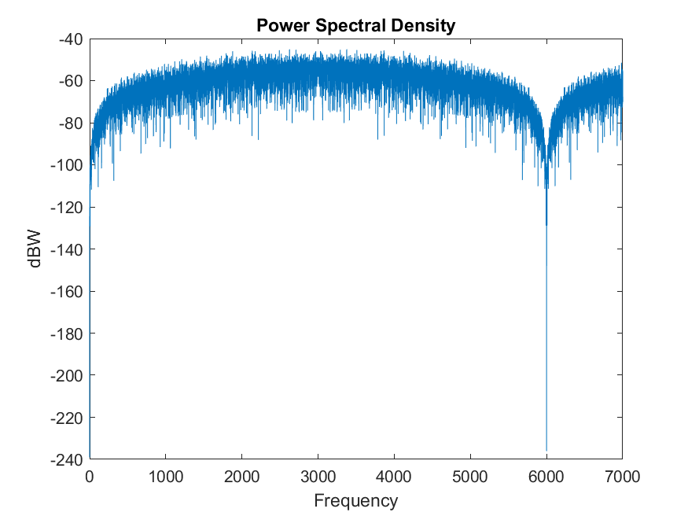

**Descriptive Answers to Tasks:**

Task 1:

Comment about plot. The plot follows a relatively predictable trend. Up until the energy per bit to signal noise gets into the higher range, there is a linear decrease in the probability of error. Towards the upper end of the range of ratios, there seems to be exponentially diminishing returns on the benefit of increase the ratio.

Task 2:

The peak of the frequencies happens every 1.5 kHz which makes sense due to the frequency of our carrier wave being 1.5 kHz. This essentially means that the we are going to due to the cosine carrier wave, we are getting almost perfectly oscillating frequency peaks when we perform the FFT and plot the power spectral density.

**Conclusion:**

Overall, my understanding of pass-band signal filtering of binary encoded signals is that pass-band signals are great for sending a binary encoded signal over a large number of frequencies. Observing the probability of error allows us to understand that we are losing significant amounts of the signal when we have a negative energy per bit to signal noise ratio. This, in combinations with the plot of the power spectral density allow us to understand that the versatility over features loses the ability for this program to operate efficiently at lower frequencies while also struggling at higher frequencies.